This versatile software operates ChemInstruments test platforms with point and click commands and provides test data results in report ready format. Remote operation and data collection are now on your computer at your fingertips
EZ-LAB SYSTEM

- One common screen contains all commands even calibration sequence.
- Test data is graphed immediately upon test completion.
- Cropping feature provides more detail analysis and selected views.
- Files can be saved to two additional locations.
- Test data files can be transferred across networks and the internet.
- Previous test are always available for review.
- Test platforms can be operated remotely.


ChemInstruments

www.ChemInstruments.com

Adhesion Release Tester AR-1000

Features and Advantages

The ChemInstruments AR-1000 Adhesion/Release tester is ideal for performing PSA release, and peel tests. This versatile carefully designed instrument is intuitive and easy to use. Designed to perform PSTC, ASTM, TLMI, FINAT, and AFERA tests.
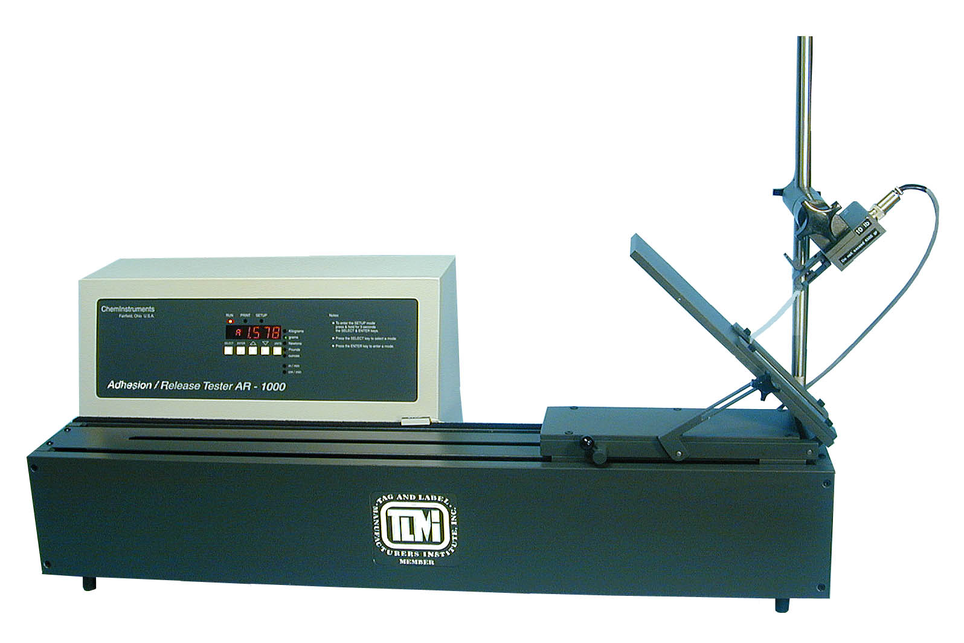
- Provides accurate, repeatable, and timely test data.
- Durable construction suitable for production floor QC testing, and the R & D lab.
- Continuous running, high torque DC drive that eliminates start/stop ramping.
- Data display includes the High, Low, & Average values.
- Units of measure can be changed with a press of a button – g, Kg, Lbs, Oz, N.
- Retains the raw data for the most recent 20 tests.
- Easy access to previously stored test results.
- Adjustable test speeds from 12 to 1200 inches per minute.
- Sampling length is variable via movable magnetic switches.
- Pre-set stops on the load cell mount allow quick setup for 90 & 180-degree tests.
- Compatible with ChemInstruments New EZ-Lab System.

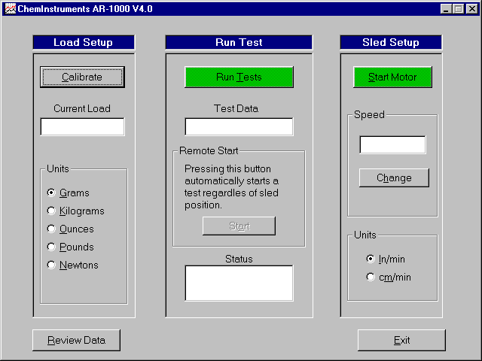
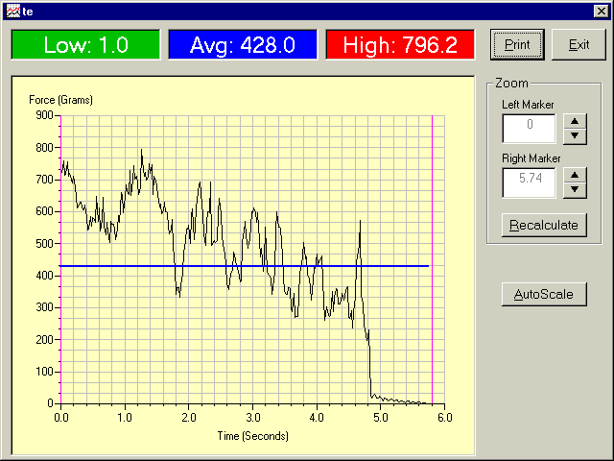

AR-1000 EZ-Lab System
- Operating controls are all on one screen.
- Save test data files to computer hard drive, disk, or other media.
- Able to crop test data graph, creating new graph.
- Able to save cropped test data graph as original file Rev.
- Print graph and notes directly from your PC screen.
- File names can be automatically sequenced.
- Previous edit notes are the default display for next file.
- Graph can be auto-scaled for enhanced presentation.
- Minimal operator involvement providing a safer test platform operation.
- Unlimited test data file retention.
- Information fields for each test data file can be edited.
- Constant real time force measurement display.
- On screen instructions for operation.

ChemInstruments

www.ChemInstruments.com

High Speed Release Tester HSR-1000

Features and Advantages

The ChemInstruments HSR-1000 High Speed Release tester is a versatile, user-friendly, carefully designed instrument that allows you to perform the most common high-speed release test.
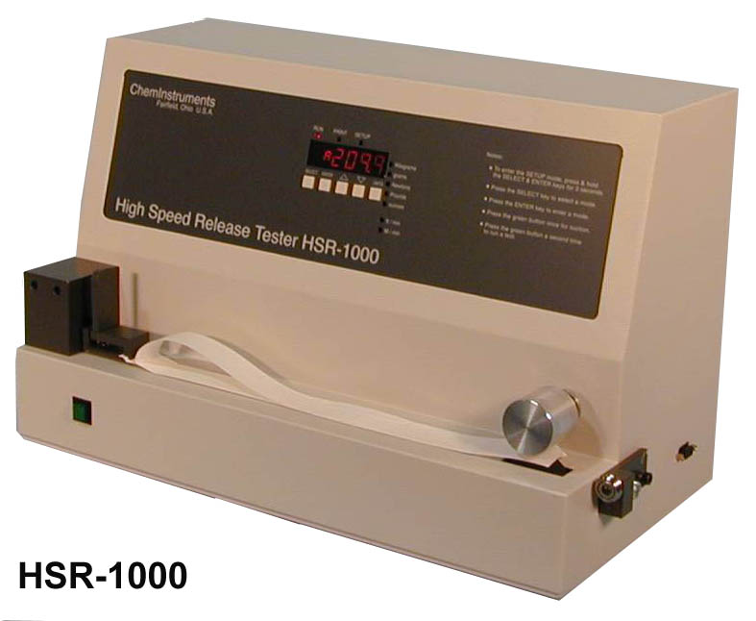
- Selectable testing speeds from 10 to 1000 feet per minute
- Predefined sample measurement area
- Four digit LED read-out
- Stores up to 20 tests or 720 seconds of data
- Displays and stores the minimum, maximum, and average test results
- Measures in; Kilograms, grams, Newtons, Pounds and ounces
- Test data can be downloaded to EZ-Stats software for analysis and printing
- Compatible with ChemInstruments New EZ-Lab System

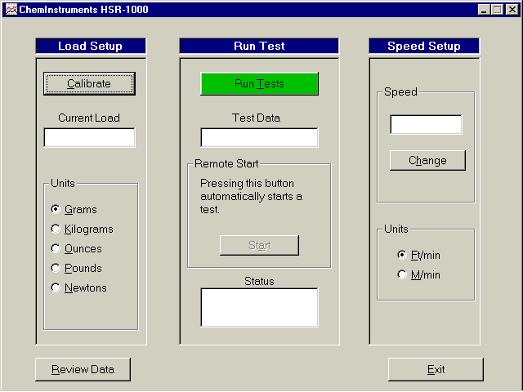
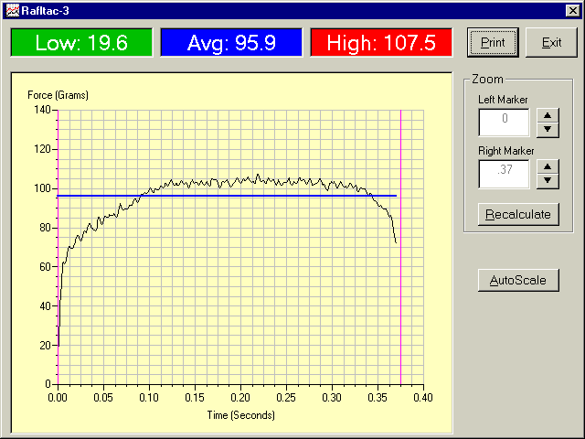
HSR-1000 EZ-Lab System

- Operating controls are all on one screen.
- Save test data files to computer hard drive, disk, or other media.
- Able to crop test data graph, creating new graph.
- Able to save cropped test data graph as original file Rev.
- Print graph and notes directly from your PC screen.
- File names can be automatically sequenced.
- Previous edit notes are the default display for next file.
- Graph can be auto-scaled for enhanced presentation.
- Minimal operator involvement providing a safer test platform operation.
- Unlimited test data file retention.
- Information fields for each test data file can be edited.
- Constant real time force measurement display.
- On screen instructions for operation.

ChemInstruments
www.ChemInstruments.com

Loop Tack Tester LT-1000

Features and Advantages

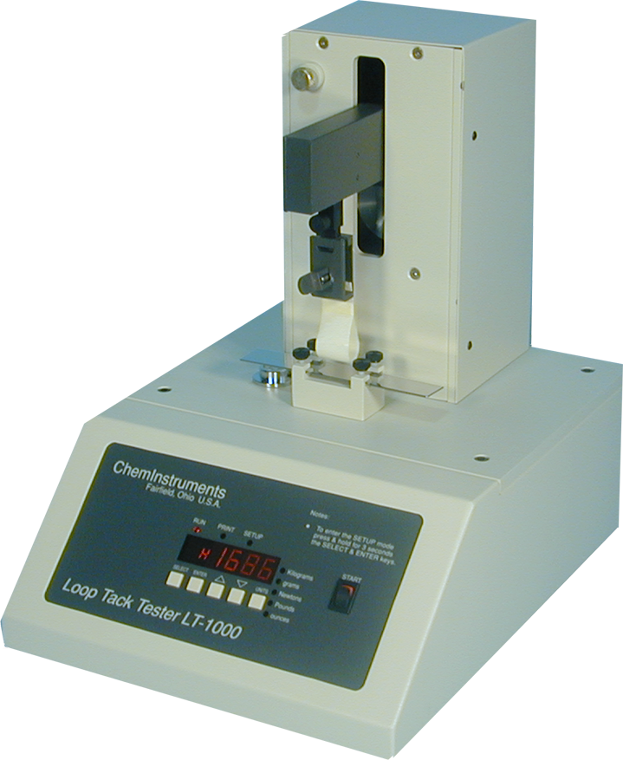
The ChemInstruments LT-1000 Loop Tack Tester is a versatile, user friendly, carefully designed instrument, which allows you to determine loop tack values of adhesive laminates.

- Automated test sequence
- Selectable units of measure; Kilograms, grams, Newton’s, Pounds & ounces
- Memory storage of up to 20 tests
- Collected data can be exported via RS232 port
- Stored test data is available for review
- Compatible with ChemInstruments New EZ-Lab System

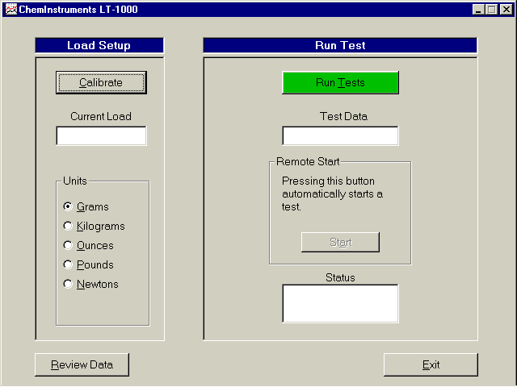
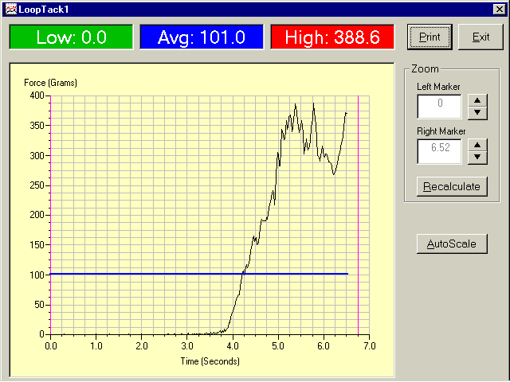
LT-1000 EZ-Lab System

- Operating controls are all on one screen.
- Save test data files to computer hard drive, disk, or other media.
- Able to crop test data graph, creating new graph.
- Able to save cropped test data graph as original file Rev.
- Print graph and notes directly from your PC screen.
- File names can be automatically sequenced.
- Previous edit notes are the default display for next file.
- Graph can be auto-scaled for enhanced presentation.
- Minimal operator involvement providing a safer test platform operation.
- Unlimited test data file retention.
- Information fields for each test data file can be edited.
- Constant real time force measurement display.
- On screen instructions for operation.

ChemInstruments

www.ChemInstruments.com

Tensile Tester TT-1000

Features and Advantages

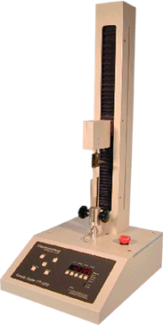
The ChemInstruments TT-1000 Tensile Tester is a versatile, user-friendly, carefully designed instrument that allows you to perform common tensile, compression, cycle, elongation measurement and numerous other tests with the appropriate fixtures.

- Selectable testing speeds from 0.2 to 25 inches per minute
- User-selectable data acquisition area
- Four digit LED read-out
- Stores up to 20 tests or 720 seconds of data
- Displays and stores the minimum, maximum, average and elongation test results
- Measures in; Kilograms, grams, Newtons, Pounds and ounces
- Testing distance of 17 inches
- Supports load cells of 25 or 50 pounds
- Test data can be downloaded to EZStats software for analysis and printing
- Automatic overload protection during downward movement
- Automatic return to test start position for running multiple tests
- Preset jog speed of 15 inches per minute
- Compatible with ChemInstruments New EZ-Lab System

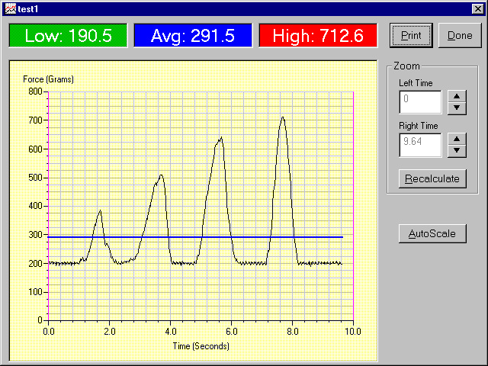
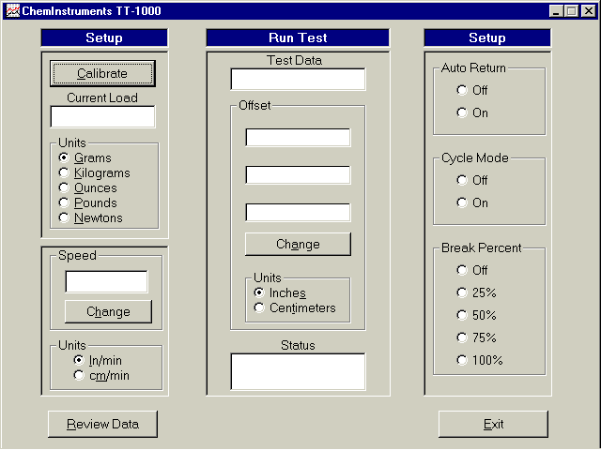
TT-1000 EZ-Lab System
- Operating controls are all on one screen.
- Save test data files to computer hard drive, disk, or other media.
- Able to crop test data graph, creating new graph.
- Able to save cropped test data graph as original file Rev.
- Print graph and notes directly from your PC screen.
- File names can be automatically sequenced.
- Previous edit notes are the default display for next file.
- Graph can be auto-scaled for enhanced presentation.
- Minimal operator involvement providing a safer test platform operation.
- Unlimited test data file retention.
- Information fields for each test data file can be edited.
- Constant real time force measurement display.
- On screen instructions for operation.

ChemInstruments

www.ChemInstruments.com

